South Metropolitan TAFE

Munster Campus

Applied Engineering

AGV Mecanum Platform

P

Advanced Diploma in Engineering - Mechanical

Author

Student ID

Date

## Abstract

*In this section you are to write a brief summary of the report. The abstract should be:*

* *An appropriate length.*
* *A complete summary of key information.*
* *Informative, not descriptive, in form.*
* *Impersonal in tone.*
* *Written with connected prose.*

*Remove ALL italicised instructional text found in this document prior to submitting your assignment.*

Table of Contents

Abstract 2

Introduction 4

AGV Platforms 4

Design Concept 4

Problems associated with the design 4

Design Components & Material Selection 4

Mecanum Wheel 5

Frame 5

Lifting Mechanisms 5

Drive System 5

Control System 5

Calculations 6

Costings 6

Discussion and Conclusion 6

Recommendations 6

References 6

List of Figures 6

List of Tables 6

Appendix 6

## Introduction

*This section must address the following criteria:*

* *Relating topic to wider field.*
* *Necessary background information.*
* *Purpose of report.*
* *Scope of report.*
* *Explanation of arrangement of report.*
* *Sections.*

## AGV Platforms

*This section should give an explanation of what AGV platforms are, how they operate, their uses, how they’re powered, lift capacities, price ranges, etc.*

## Design Concept

*This section should give an outline of the criteria from which the design was based.*

*Eg. lift capacity, speed limits, overall size, standards, etc. Be thorough in this section.*

## Problems associated with the design

*In this section, discuss any issues or problems that were associated with the initial design and who they were resolved.*

*Eg. Client amendments, lift mechanism problems, wheel/roller issue, off-the-shelf parts availability, etc.*

## Design Components & Material Selection

*In this section, discuss how you went about the design from initial brain storming, sketching, etc. through to the finished part/assembly. Be sure to include any sketches, images and notes that are relevant to the part. Discus any events that may have had an impact on the final design outcome, eg. High cost of initial design, availability of material, etc. Be sure to include your material selection criteria.*

*This section should be a compilation of individual work, that is, each student should only write about the parts they were involved with and any other team member that may have contributed to your design. Be sure to include any relevant specifications such as weight, dimensions, power, etc.*

### Mecanum Wheel

*Rollers, Cheek Plates, Hub, Bearings, Axles, Urethane..*

*Place content here.*

### Frame

Designed by Bryce Richards

Design of the frame was simple but with a number of dependencies. This was started early as a ‘placeholder’ due to the design being bottom-up with an understanding that there would be a need for later revisions as other parts such as the lifting device were finalised. At a basic level it needed to fit through the required doorway, under the platforms to be lifted, and stay rigid under the specified load.

All parts were designed to use standard sizes of mild steel SHS. This was due to high availability, low cost, easy recyclability, and ease of manufacturing.

MecanumChassis2.iam:

Based on the scope document the maximum size of the Mecanum AGV was 795mm (w) x 800mm(l) x 250mm(h).[1] These dimensions were used to create a simple wireframe and the Inventor Frame Editor was used to produce an SHS model. An assumption was made that the wheels would each be 125mm wide, therefore leaving 545mm of width for the frame. Design size was set to 800x545mm. Initially 45x45x1.6mm SHS was selected. An iterative process was used via which a size of SHS was selected, tested in the ‘Frame Analysis’ environment, then revised accordingly. The process repeated until a final selection was made of 35x35x1.6mm SHS which could tolerate the 500kg load with < 300MPa stress.

Two changes were necessary to the frame as the project progressed:

1. Once the design for the wheel hub was finalised it became apparent that the full 545mm was not available. The width of the frame was therefore reduced to 515mm to allow space for outboard nuts on the axle.
2. Late in the project Ross revised the scope up from a 500kg maximum payload to 1000kg maximum payload. Due to this it was necessary to increase the SHS thickness to 3mm.

LiftPlate.iam:

The lift plate followed the basic design of the chassis described above including late-stage reductions in width and increases in thickness. Design of this part was ultimately dependent on the lifting mechanism. The size of the gearbox for the lifting device determined the final size of the lifting plate – this caused the team to move the position of the legs of the lift plate to align with this device.

Following the above a group of 2D drawings were produced for fabrication. These were of the top and bottom of the chassis, and then the lifting plate (see figures A, B and C). These 2D drawings were used to cut and weld the selected 35x5x3mm SHS as required.

Cutting SHS to length:

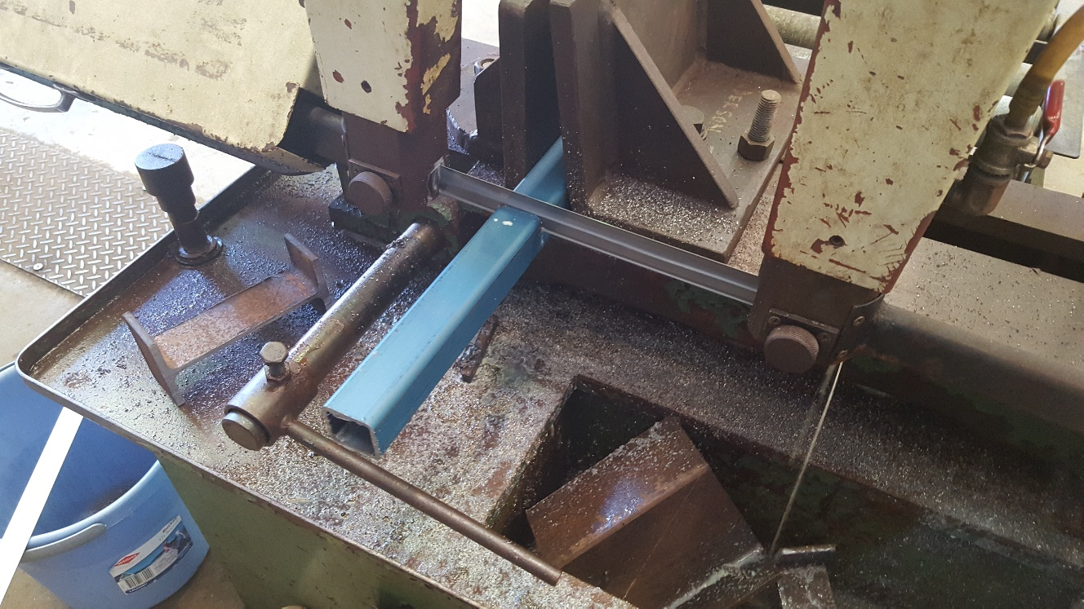

Cutting SHS 45° angles:

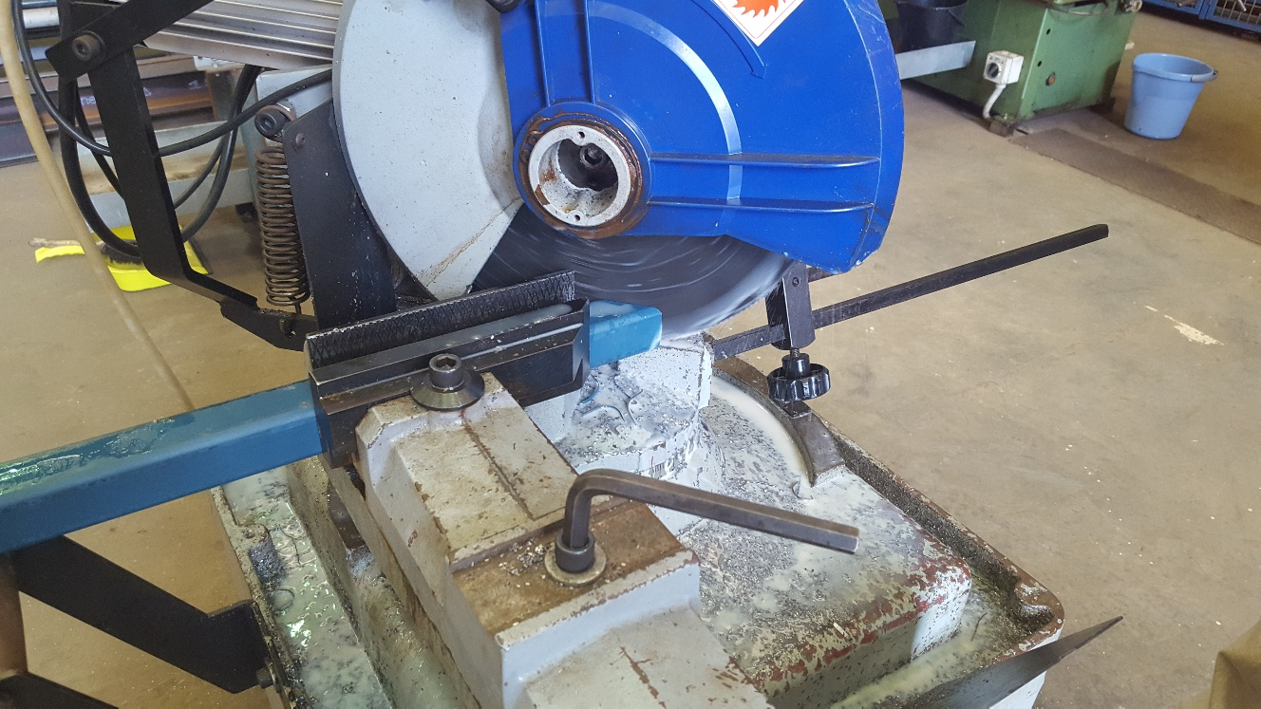

Preparation for welding SHS:

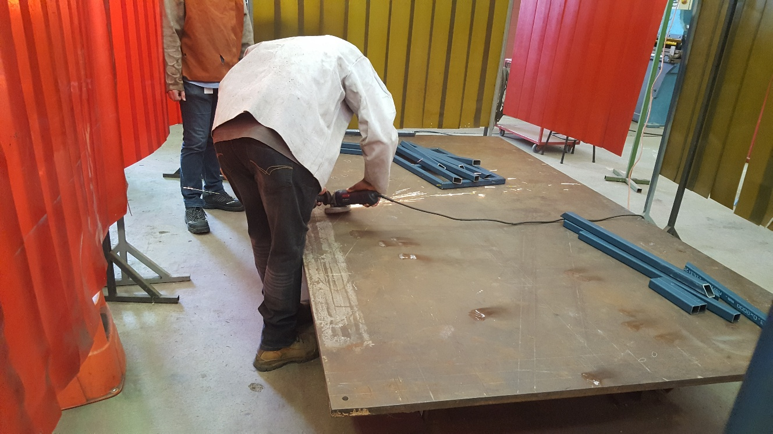

Top frame welded:

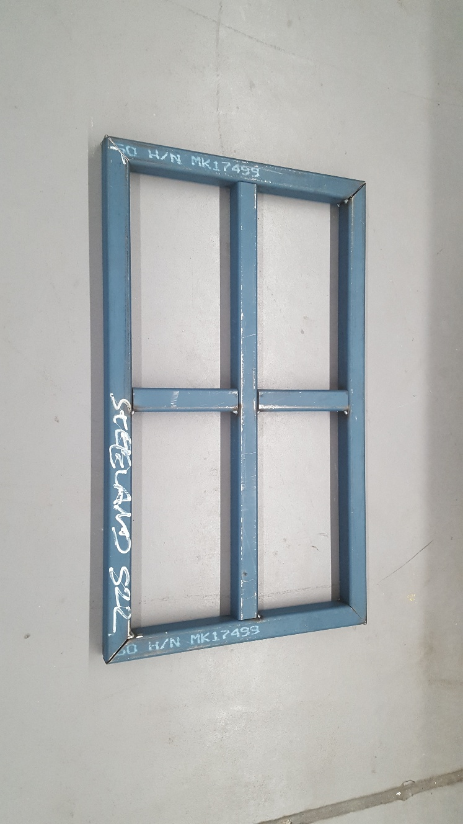

Base frame welded:

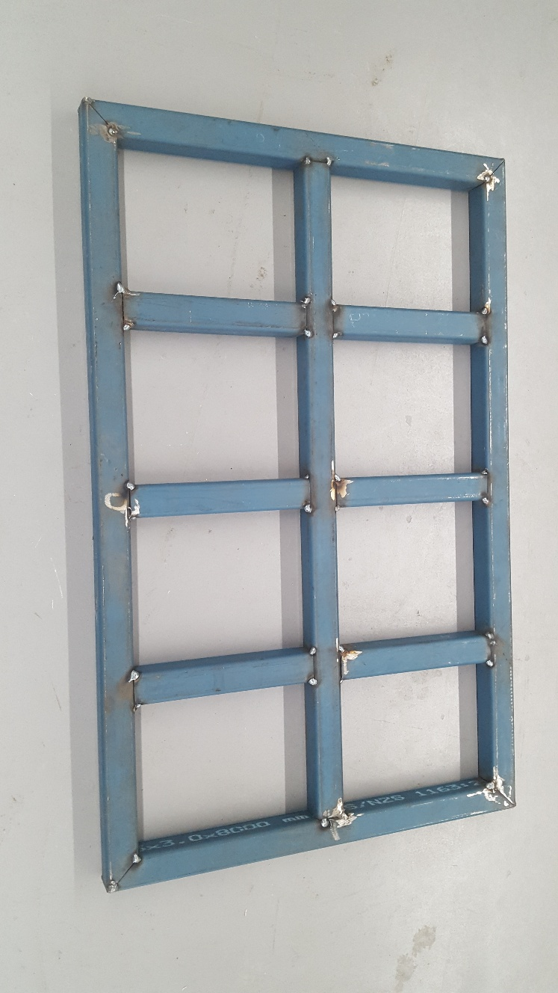

Figure A: MECANUM_BASE1.dwg

Figure B: MECANUM_BASE2.dwg

Figure C: MECANUM_TOP.dwg

### Lifting Mechanisms

*Electro-mechanical: Gearbox, motor, ball screw, bearings, linear rail, etc.*

*Pneumatic: Compressor, receiver, air bag, etc.*

*Place content here.*

### Drive System

*Motors, Shafts, bearings, axles, pulleys, belts, brackets, etc.*

*Place content here.*

### Control System

*Motor controllers, electronics (sensors, encoders), etc.*

*Place content here.*

## Calculations

*This section should show all calculations carried out for each component as well as the operation of the platform including any FEA, shear force diagrams, bending moment diagrams, excel sheets, hand written calculations, weld calculations.*

*Eg, speeds, forces, moments, torque, deflection, etc.*

*This section should also include the total weight of the platform.*

## Costings

*This section should outline all costs associated with the project. Be sure to include any quotes for materials, machining, off-the-shelf items, etc.* (p. 1)

## Discussion and Conclusion

*In this section, discuss the viability of your design in terms of the total cost involved, whether your objectives were met, client expectations, etc.*

## Recommendations

*In this section, discuss any recommendations you may have to further improve your design, manufacturing processes, materials, and handing the project over to a third party, any experience you have gain that may be beneficial, etc.*

## 

## References

APA referencing style

## List of Figures

## List of Tables

|  |  |
| --- | --- |
|  |  |

## Appendix

1. Richards, B. (2017). *Scope Statement – Mecanum AGV Project: Project Description*